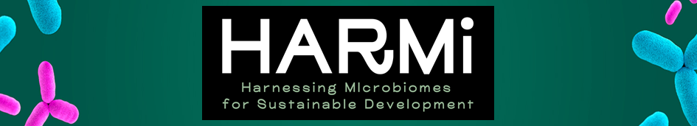

Young talents program
(Tenure-eligible Junior Lecturer Chair Position)

Exploring antibiotic resistance in human pathogens
in the One Health framework

Job number: HARMI-YTP-2026-01

Job description and environment
The Chair is part of the HARMI « ExcellencES » project (Harnessing Microbiomes for sustainable development) funded by the French government's Investment for the Future Program (France 2030). The HARMI project aims at creating the first European Interdisciplinary Centre of Excellence in the Bourgogne Franche-Comté region dedicated to the use of the microbes for addressing the most crucial societal and environmental challenges (https://www.umlp.fr/harmi).

HARMI provides funding for talented young researchers (experience > 5 years after PhD) the opportunity to pursue their ideas and lead a research project focused on the study of antibiotic resistance in human pathogens in the context of One Health. The HARMI funding includes a full salary for the grant holder, along with up to 180 000 euros to support the recruitment of a postdoctoral researcher and to cover research-related expenses. The research themes include (i) mechanisms underlying the emergence and spread of antibiotic-resistant bacterial pathogens in the human, animal and environmental sectors, (ii) population structure of antibiotic-resistant pathogens. We welcome applications from candidates working in the fields of antibiotic resistance, microbial ecology, microbial epidemiology, and related areas.

The recruited candidate will be based at the UFR Sciences de la Santé in Besançon (Université Marie et Louis Pasteur, UMLP) within the UMR 6249 Chrono-environnement department (https://chrono-environnement.univ-fcomte.fr). The department comprises 5 research sections and over 280 staff members, including microbiologists, ecologists, chemists, molecular biologists, bioinformaticians, and mathematicians. The candidate will join the ‘Pathogenic Agents’ section and will have access to four platforms: a microbial biobank, a molecular biology platform, an animal facility, and a bioinformatics platform). The position is expected to contribute to the missions of the department and UMLP mission to understand the spread of antimicrobial resistance and help prevent future outbreaks in a One Health framework. The selected candidate will be expected to teach approximately 50 hours per year.

Training and skills
The Junior Professor Chair is intended for scientists with a PhD who have already demonstrated their capacity to produce excellent research, as evidenced by a strong record of high-quality publications in international peer-reviewed journals. The position is primarily dedicated to research. The person recruited will hold a PhD in Microbiology or a related field, with at least five years of independent and demonstrable research experience following completion of the PhD. Knowledge in resistance to antibiotics and microbial epidemiology would be particularly appreciated. Experience in supervision and in leading or contributing to national, European or international research projects is strongly recommended.

Type of contract
The person recruited will be provided a 400 k€ grant (covering salary for the position and for a postdoctoral researcher, consumables, travels, small equipment, etc.) for a three-year period, supported by the HARMI Excellence project funded by the French 2030 program. The salary will be negotiated based on the candidate’s education and experience. Recruitment will be carried out by the UMLP, which offer a comprehensive benefits package including retirement, health insurance, annual and sick leave. During the three-year period, the successful candidate will be committed to apply for a European Research Council (ERC) grant. At the end of this period, and following an evaluation of the candidate’s scientific achievements and professional potential, he/she may obtain an Assistant Professor Position by applying to the UMLP open competition within the UFR Sciences de la Santé (UMR 6249 Chrono-environnement).

Application
We invite the interested candidates to follow the link https://www.umlp.fr/harmi to download the form to be filled and returned by email to harmi@ubfc.fr, before May 1st, 2026. Only candidates selected by a jury based on their application will be invited to the hearing.

For additional information, please contact harmi@ubfc.fr and didier.hocquet@umlp.fr

